The Lightweight IBM Cloud Garage Method for Data Science

Architectural Decisions Document Template

# Architectural Components Overview

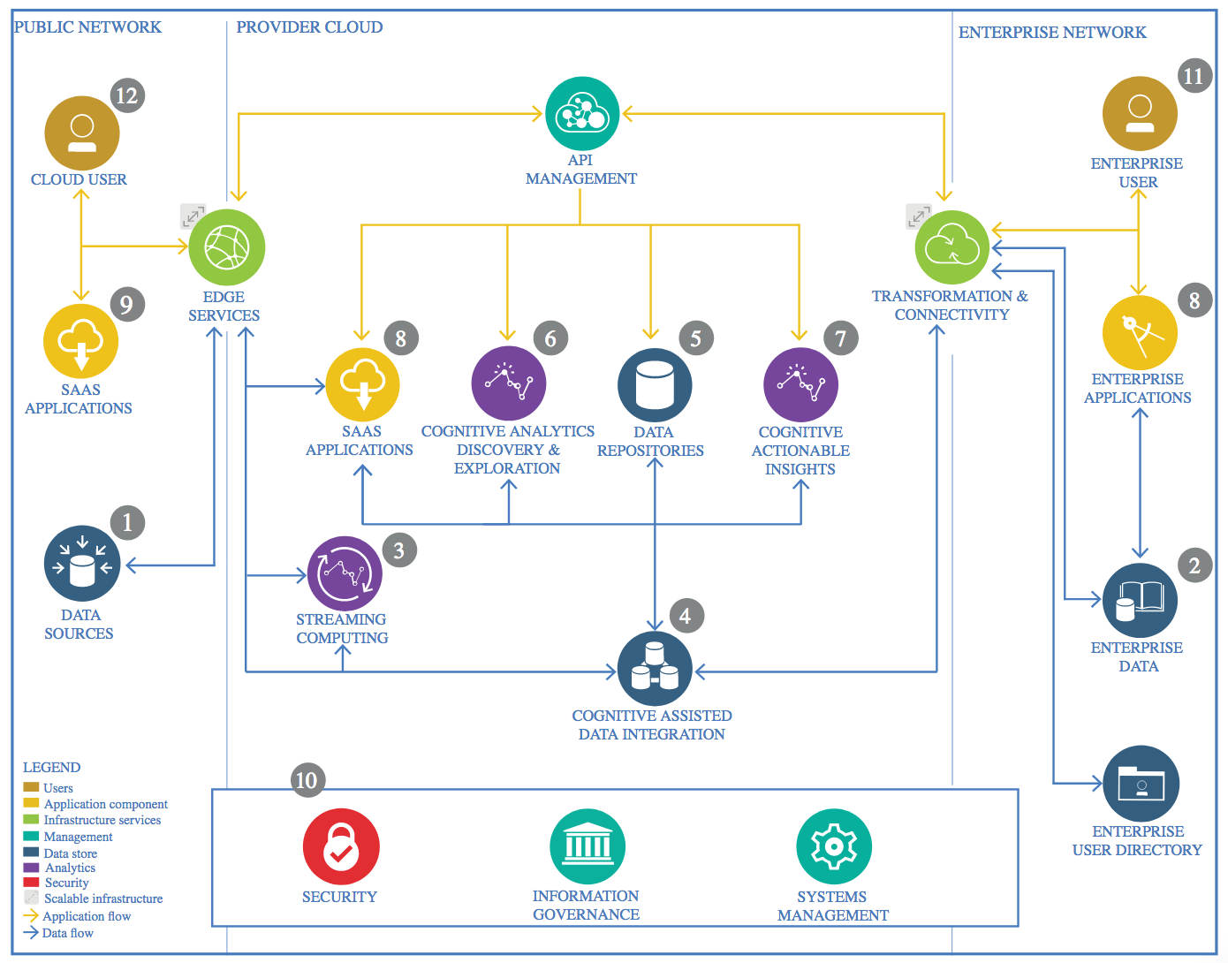

IBM Data and Analytics Reference Architecture. Source: IBM Corporation

## Data Source

Credit card fraud detection dataset from Kaggle ,which public available

https://www.kaggle.com/datasets/mlg-ulb/creditcardfraud

### Technology Choice

Please describe what technology you have defined here. Please justify below, why. In case this component is not needed justify below.

We are using python as programming tool and some Machine learning algorithm like random forest classifier ,XG boost classifier & Forward neural network

### Justification

Python has the most library that are used for machine learning algorithm ,data cleaning and processing are very easy in Python & its open source softwate

## Enterprise Data

N/A

### Technology Choice

N/A

### Justification

N/a

## Streaming analytics

### Technology Choice

N/A

### Justification

N/A

## Data Integration

### Technology Choice

N/A

### Justification

Single dataset in the form of CSV

## Data Repository

### Technology Choice

N/a

### Justification

N/A

## Discovery and Exploration

### Technology Choice

N/A.

### Justification

## Actionable Insights

### Technology Choice

N/A

### Justification

Will able to detect the fraud transaction

## Applications / Data Products

### Technology Choice

N/A

### Justification

N/A

## Security, Information Governance and Systems Management

### Technology Choice

N/A

### Justification

Public dataset